God Is Our Fortress

Some of my friends and brethren have suffered loss of loved ones in 2019. I know of others who are battling serious illnesses and other hardships. It would be easy to become discouraged and depressed under these circumstances. God does not promise His children escape from trials. However, God has not left us without hope!
The good news we serve a living God! A God who cares for us in times of great difficulty. Our hope is in heaven, however, we also have hope and encouragement right now!

Psa 46:1 God is our refuge and strength, a very present help in trouble.

Pro 18:10 The name of the LORD is a strong tower: the righteous runneth into it, and is safe.
Our Lord is a strong tower for those who are right before God and can go to Him in prayer for help. I often think of those in the world who deny there is a God how they survive when calamity comes to them.
God has given His people great hope and encouragement in this life and certainly the one to come. We need to be constantly reminded of this especially when sorrow and despair visits us.

Be of good courage!
Psa 31:24 Be of good courage, and he shall strengthen your heart, all ye that hope in the LORD.

What should we do when faced with a great tragedy in our lives?
Psa 46:10 Be still, and know that I am God: I will be exalted among the heathen, I will be exalted in the earth.

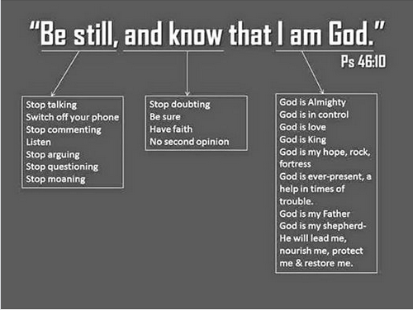
Source: Glenda Schales
The answer is “Be Still”. …. Don’t say or do anything rashly. Be reminded that God is King and no other is. Know that God can move mountains and tame raging rivers.
Psa 46:3 Though the waters thereof roar and be troubled, though the mountains shake with the swelling thereof. Selah.
Psa 46:4 There is a river, the streams whereof shall make glad the city of God, the holy place of the tabernacles of the most High.
Psa 46:5 God is in the midst of her; she shall not be moved: God shall help her, and that right early.

We have what the ungodly don’t, a relationship with the almighty true and living God!
Of course, God never promised that His people will be removed from the trials of this world but He does give us a refuge a place to go to be able endure whatever comes our way. God gives us mental strength to persevere no matter what comes our way. We know God has not abandoned us nor will His promises be broken.

Read how the Apostle Paul viewed his sufferings:
2Co 4:8 We are troubled on every side, yet not distressed; we are perplexed, but not in despair;
2Co 4:9 Persecuted, but not forsaken; cast down, but not destroyed;
2Co 4:16 For which cause we faint not; but though our outward man perish, yet the inward man is renewed day by day.
2Co 4:17 For our light affliction, which is but for a moment, worketh for us a far more exceeding and eternal weight of glory;
2Co 4:18 While we look not at the things which are seen, but at the things which are not seen: for the things which are seen are temporal; but the things which are not seen are eternal.

Rom 8:18 For I reckon that the sufferings of this present time are not worthy to be compared with the glory which shall be revealed in us.

Whatever trial or suffering we are undergoing; it will not be for eternity. We also are aware that God has not abandoned us.
Psa 46:2 Therefore will not we fear, though the earth be removed, and though the mountains be carried into the midst of the sea;

As for New Year resolutions……keep this word from our Father in mind:

Heb 13:5 Keep your life free from love of money, and be content with what you have, for he has said, “I will never leave you nor forsake you.”

John Smith

